**Lab Number: 05**

**To learn conceptual and logical DW Design**

1. **Draw M/ERDs for the following scenarios represented by ERDs and business rules to ease your task.**
2. **Scenario 1: Advertising**



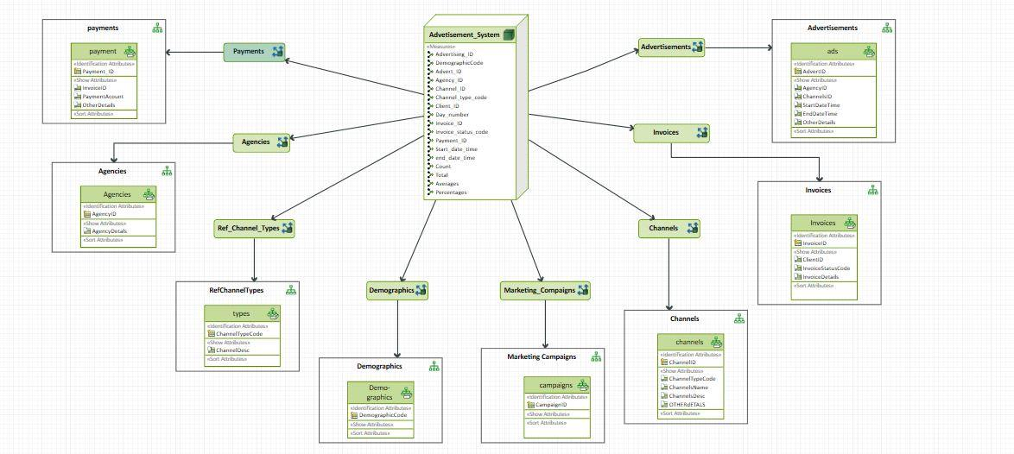

1. **Scenario 2: Amusement Parks**



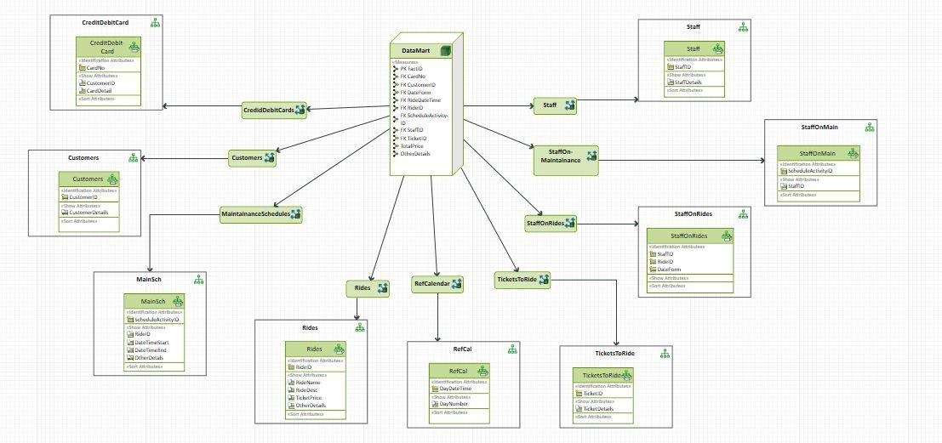

1. **Scenario 3: Clown registry**

